1-Validation
# Source: Chatgpt (GPT-5-Mini) at [1/20/2026]
Validation is the process of checking user input to ensure it is:
- Correct
- Complete
- Within expected formats and boundaries
- Safe to use (e.g., free from malicious content)
It is a fundamental part of web and application security and data integrity.

🎯 Types of Validation

1. Client-Side Validation
# Source: Chatgpt (GPT-5-Mini) at [1/20/2026]
- Done in the browser (usually using JavaScript or HTML5).
- Provides immediate feedback to the user.
- Example: checking if an email address is valid before submitting a form.
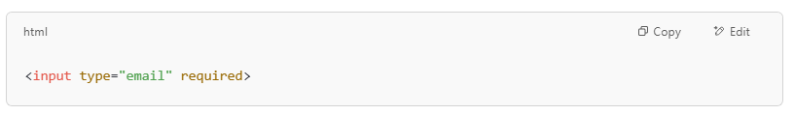
<input type="email" required>

2. Server-Side Validation
# Source: Chatgpt (GPT-5-Mini) at [1/20/2026]

- Done on the server after form submission.
- Critical for security because client-side checks can be bypassed.
- Example in PHP:
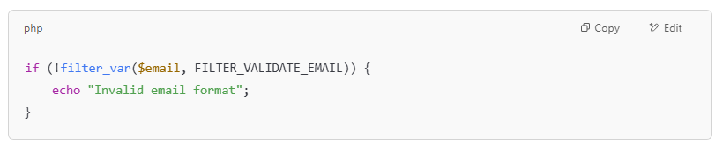
if (!filter_var($email, FILTER_VALIDATE_EMAIL)) {
echo "Invalid email format";
}

📋 Examples of What Validation Checks For
# Source: Chatgpt (GPT-5-Mini) at [1/20/2026]
- Required fields are not empty
- Data types are correct (e.g., numbers, dates)
- Values are within expected ranges (e.g., age > 0)
- Input length is acceptable
- Format matches expected pattern (e.g., phone number or email format)
- Input does not contain dangerous characters (e.g., <script> tags)

🔒 Why Validation Matters
# Source: Chatgpt (GPT-5-Mini) at [1/20/2026]
- Prevents errors and improves user experience
- Protects against security threats like:
  - SQL Injection
  - Cross-Site Scripting (XSS)
  - Command injection
- Ensures data quality and consistency

🧠 Validation vs. Sanitization
# Source: Chatgpt (GPT-5-Mini) at [1/20/2026]

Term | Purpose | Example
Validation | Checks if input is correct | Is the email valid? Is age a number?
Sanitization | Cleans input to make it safe | Remove <script> tags from a comment

2-Sanitization
# Source: Chatgpt (GPT-5-Mini) at [1/20/2026]
Sanitization is the process of cleaning user input to remove or neutralize potentially malicious content before using it in your application — especially when displaying or storing it.

🎯 Purpose of Sanitization
# Source: Chatgpt (GPT-5-Mini) at [1/20/2026]
To make user input safe to process, display, or store by:
- Removing dangerous characters (like <, >, " in HTML)
- Stripping or encoding malicious scripts
- Neutralizing injection attempts (XSS, SQL, command injection)

🔒 Why Is It Important?
# Source: Chatgpt (GPT-5-Mini) at [1/20/2026]
Sanitization helps prevent security vulnerabilities, such as:
- Cross-Site Scripting (XSS)
- SQL Injection
- HTML Injection
- Command Injection

🧠 Sanitization vs. Validation
# Source: Chatgpt (GPT-5-Mini) at [1/20/2026]
Concept | Purpose | Example
Validation | Is the input correct? | Is it a valid email address?
Sanitization | Is the input safe? | Remove <script> from input
Both are important and often used together.

🧪 Examples
# Source: Chatgpt (GPT-5-Mini) at [1/20/2026]

1. HTML Sanitization (e.g., Preventing XSS)
# Source: Chatgpt (GPT-5-Mini) at [1/20/2026]
User input:
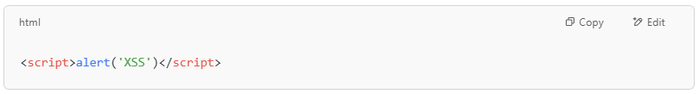
<script>alert('XSS')</script>

Sanitized Output: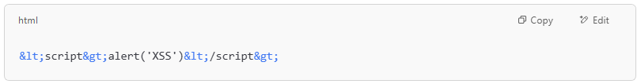
&lt;script&gt;alert('XSS')&lt;/script&gt;

In JavaScript:
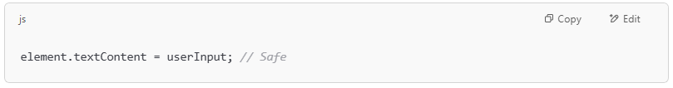
element.textContent = userInput; // Safe

2. Using a Sanitization Library
# Source: Chatgpt (GPT-5-Mini) at [1/20/2026]
- JavaScript (DOMPurify):
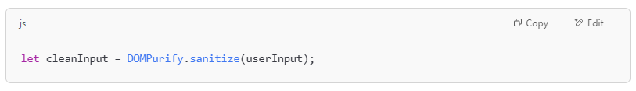
let cleanInput = DOMPurify.sanitize(userInput);

- PHP (strip_tags):
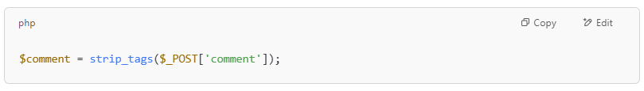
$comment = strip_tags($_POST['comment']);

- Python (Django) (auto-escaping is built-in in templates)

🛡️ Tips for Secure Input Handling
# Source: Chatgpt (GPT-5-Mini) at [1/20/2026]
- Validate first, sanitize second.
- Escape output based on context (HTML, JS, SQL, etc.).
- Use safe DOM methods (textContent, createTextNode, etc.).
- Use well-maintained libraries for sanitization.

3-Escaping output
# Source: Chatgpt (GPT-5-Mini) at [1/20/2026]
Escaping output means converting special characters in user-generated data into a safe format before displaying it in a web page or application. This prevents malicious input (like scripts) from being executed by the browser.

🎯 Purpose
# Source: Chatgpt (GPT-5-Mini) at [1/20/2026]
Escaping output is used to neutralize potentially dangerous content — especially in contexts like HTML, JavaScript, or SQL — to prevent vulnerabilities such as:
- Cross-Site Scripting (XSS)
- HTML/Attribute Injection
- JavaScript Injection

🧪 Example: Without Escaping
# Source: Chatgpt (GPT-5-Mini) at [1/20/2026]
User input: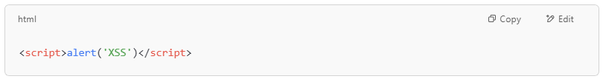
<script>alert('XSS')</script>

Displayed without escaping:
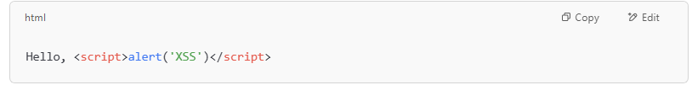
Hello, <script>alert('XSS')</script>

➡️ Browser executes the script — XSS attack occurs.

✅ Example: With Escaping
# Source: Chatgpt (GPT-5-Mini) at [1/20/2026]
Escaped output: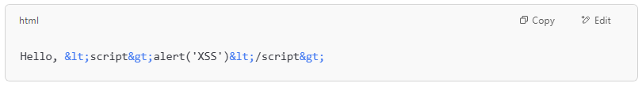
Hello, &lt;script&gt;alert('XSS')&lt;/script&gt;

➡️ The script is shown as plain text — safe.

🧠 Key Concept: Escape Based on Context
# Source: Chatgpt (GPT-5-Mini) at [1/20/2026]
Different output contexts require different escaping:

Context | Example Characters to Escape | Method
HTML | <, >, &, " | htmlspecialchars() in PHP, escape() in Django
JavaScript | ', ", \, / | Use JSON encoding or context-aware escape
URL (href) | ?, &, =, spaces | encodeURIComponent() in JavaScript
SQL | ', " | Use prepared statements (not just escaping)

🔧 Code Examples
# Source: Chatgpt (GPT-5-Mini) at [1/20/2026]
PHP:
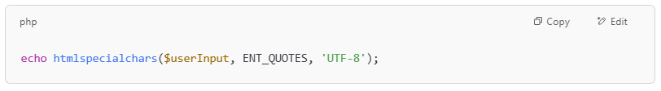
echo htmlspecialchars($userInput, ENT_QUOTES, 'UTF-8');

JavaScript (safe HTML display):
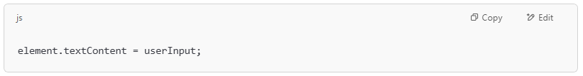
element.textContent = userInput;

Python (Django Template):
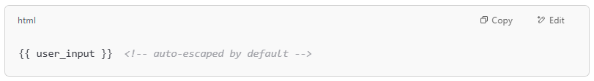
{{ user_input }} <!-- auto-escaped by default -->

🛡️ Escaping vs. Sanitizing vs. Validating
# Source: Chatgpt (GPT-5-Mini) at [1/20/2026]

Concept | Purpose | Example
Validate | Check if input is correct | Is it an email? A number? Required?
Sanitize | Clean input to make it safe | Remove tags, strip bad characters
Escape | Encode output for safe display | Turn < into &lt; before rendering HTML

Escaping vs. Sanitizing
# Source: Chatgpt (GPT-5-Mini) at [1/20/2026]

🧠 Easy Definition Summary:
# Source: Chatgpt (GPT-5-Mini) at [1/20/2026]
Concept | What it does | When it's used
Sanitizing | Cleans input (removes bad stuff) | At input (before storing or using)
Escaping | Encodes output (prevents execution) | At output (before displaying)

🔑 Think of it like this:
# Source: Chatgpt (GPT-5-Mini) at [1/20/2026]
- Sanitization changes or removes the dangerous parts.
- Escaping encodes characters so they can’t run as code.
They work toward the same goal (safety), but they’re not the same, and escaping is not a kind of sanitizing.

real-world examples
# Source: Chatgpt (GPT-5-Mini) at [1/20/2026]

🧪 Input From User
# Source: Chatgpt (GPT-5-Mini) at [1/20/2026]
Imagine the user submits:
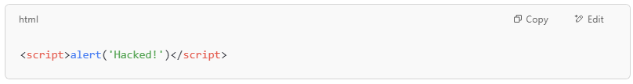

✅ 1. Sanitization Example
# Source: Chatgpt (GPT-5-Mini) at [1/20/2026]
🎯 Goal: Clean the input before using or storing it.
Example in PHP:

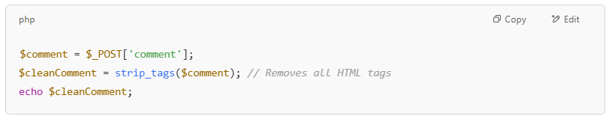
$comment = $_POST['comment'];
$cleanComment = strip_tags($comment); // Removes all HTML tags
echo $cleanComment;

Result:
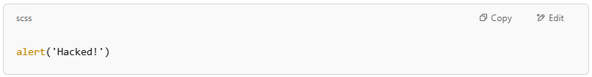
alert('Hacked!')

- ❌ Script is removed from the input.
- ✔️ Now it's safe to store or display.

✅ 2. Escaping Example
# Source: Chatgpt (GPT-5-Mini) at [1/20/2026]
🎯 Goal: Encode the input so it can’t run as code in the browser.
Example in PHP:

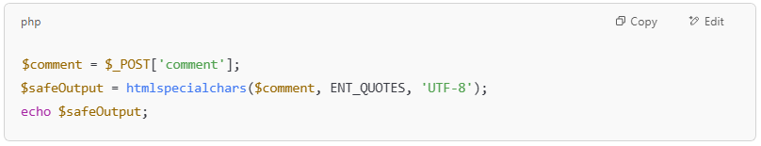$comment = $_POST['comment'];
$safeOutput = htmlspecialchars($comment, ENT_QUOTES, 'UTF-8');
echo $safeOutput;

Result:
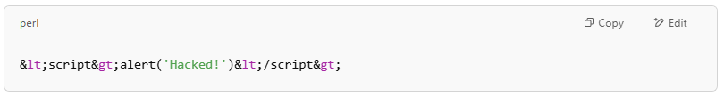
&lt;script&gt;alert('Hacked!')&lt;/script&gt;

- ❌ Script is not removed.
- ✔️ It’s shown as text, not executed.

⚠️ Key Takeaway:
# Source: Chatgpt (GPT-5-Mini) at [1/20/2026]

Action | User Input | Output | Purpose
Sanitize | <script>alert('XSS')</script> | alert('XSS') | Removes dangerous content
Escape | <script>alert('XSS')</script> | &lt;script&gt;alert('XSS')&lt;/script&gt; | Neutralizes dangerous output

🔐 When to Use Each
# Source: Chatgpt (GPT-5-Mini) at [1/20/2026]
- Sanitize input if you want to store or process data safely (In a Database, In Logs or Files, In Memory for Processing, In APIs or Background Systems).
- Escape output if you want to display data without executing it (Web Pages (HTML Output), Comments, Posts, Chat Messages, Usernames, Inside HTML Attributes, Inside JavaScript or CSS, Emails, PDFs, Excel Exports).

